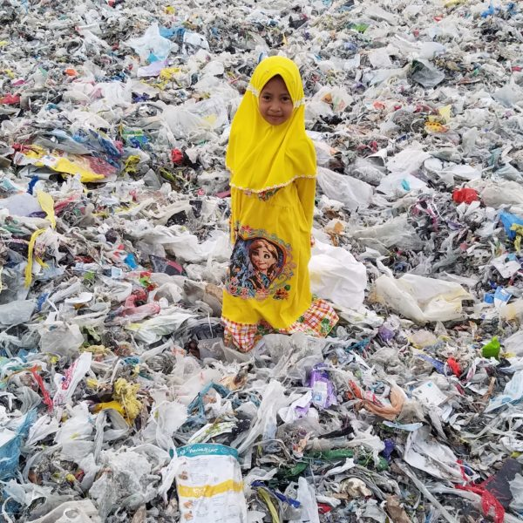

**PARAGRAPH (5 SENTENCES)**

I chose an image from my Sustainability photo essay called “Plastic and Pollution”. The image shows a young girl in a bright yellow outfit decorated with a character from Frozen. She is standing in a huge rubbish dump with lots of plastic around her. The camera angle is eye level so we look straight into her eyes. The camera shot is a long shot so we can see her head to toe. Her dress is a happy yellow colour. There is mostly white rubbish around her. White usually means pure but rubbish is dirty. The image I chose makes me feel worried about her life and about plastic pollution.

**Camera angle:**

* **Eye level**
* **Child is focus**
* **Rubbish everywhere else**

**Camera Shot:**

* **Long shot**
* **Can see child head to toe**
* **Can see rubbish everywhere else**

**Colour:**

* **Yellow dress – happy friendly sunshine**
* **White rubbish – hope clean pure good**
* **Multi-colour – red, danger blue, peace purple, royal green nature**